ES - Sprint 2 – Code Smells 2

**Comments**

Some comments can be interpreted by “reminders”, indicates that something needs to be done, or that if a change is made in one section of the code, another section must be changed or updated, indicating bad code.

* **Code Snippet**
* **Code Location**

Path: *“src\main\java\org\jabref\logic\importer\fileformat\BiblioscapeImporter.java”*

Line: 183

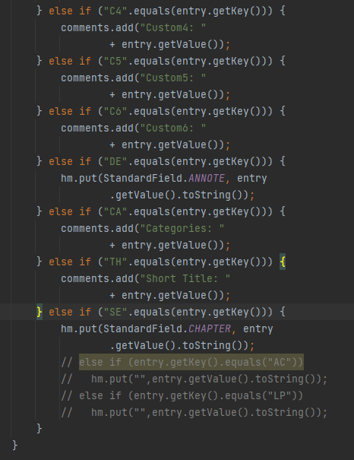

**Justification**

Like we can see there are 4 lines of comments which indicates a potential “reminder” for something that need to be implemented or updated.

**Refactoring Proposal**

In this case we should delete this comments, because they are just “reminders” for a potential implementation or update, or we make sure that we implement the rest of the method without need to update or make some alteration to another class.